****Essentials Mathematics Test #8

**60**

**Topics – Statistics & Data**

|  |  |
| --- | --- |
| **Name** |  |

* **Attempt all questions**
* **Show all working and calculations where possible**
* **Calculators are allowed**
* **One A4 page of notes is allowed**

***You must include all working out to receive full marks***

**Question 1 (10 marks)**

From the list of data displays below, choose the most appropriate way to display the data described in each part below and explain the reasons for you choice.

* Column graph
* Dot frequency diagram
* Back to back stem and leaf diagram
* Histogram

1. The heights (measured in cm) of 20 boys and 20 girls to compare them.
2. The eye colour of all Year 11 students.
3. The foot length, measured in cm, of the members of your class.
4. The percentage of students in each year at our school.
5. The heights, measured in cm, of all Essentials students.

**Question 2 (5 marks)**

This dot plot shows the foot length of a group of students.

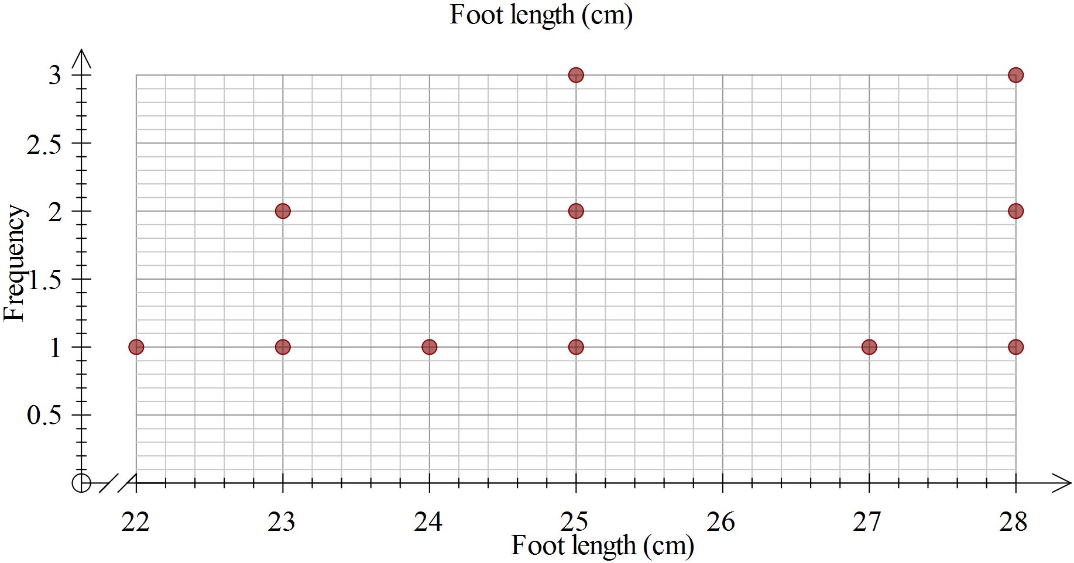

1. Calculate the range of the scores, showing your working.
2. Determine the mode.
3. Determine the median.
4. Calculate the mean, showing your working.
5. Complete this sentence: For a student in this group, you would expect them to

have a foot length of about ______cm.

**Question 3 (3 marks)**

Two classes are marked on the same tests.

Class P has a mean of 65% and standard deviation of 5.

Class Q has a mean of 50% and standard deviation of 15.

1. Write a statement comparing the scores of the two classes, that is who had the better scores?
2. Write a statement comparing the spread of the scores for the two classes.
3. Which class would you expect to have the highest score? Explain.

**Question 4 (20 marks – 2, 8, 6, 4)**

|  |  |
| --- | --- |
| Height (cm) | |
| Year 7 students | |
|  |  |
| Female | Male |
| 106 | 141 |
| 142 | 142 |
| 143 | 148 |
| 144 | 148 |
| 147 | 149 |
| 147 | 149 |
| 152 | 150 |
| 152 | 150 |
| 153 | 154 |
| 153 | 154 |
| 155 | 156 |
| 155 | 156 |
| 157 | 157 |
| 160 | 158 |
| 162 | 159 |
| 164 | 164 |
| 165 | 165 |
| 170 | 169 |
| 172 | 170 |
| 176 | 170 |

Consider the data to the right, showing the heights of 20 male and 20 female Year 7 students, taken from CensusAtSchool.

1. Circle or highlight any outliers in the data.

For any you find, explain why you consider it an outlier.

1. Use the grid paper provided to make a back-to-back stem and leaf diagram to display this data.
2. Complete the table below, showing your working, to summarize the statistics for this data.

|  |  |  |
| --- | --- | --- |
| Statistic | Female | Male |
| Mode |  |  |
| Median |  |  |
| Range |  |  |

1. Using your stem and leaf plot and/or the table in c), compare the data for males and females.

In what ways are the two groups similar?

In what ways are the two groups different?

**Question 5 (22 marks-2, 10 ,4 , 6)**

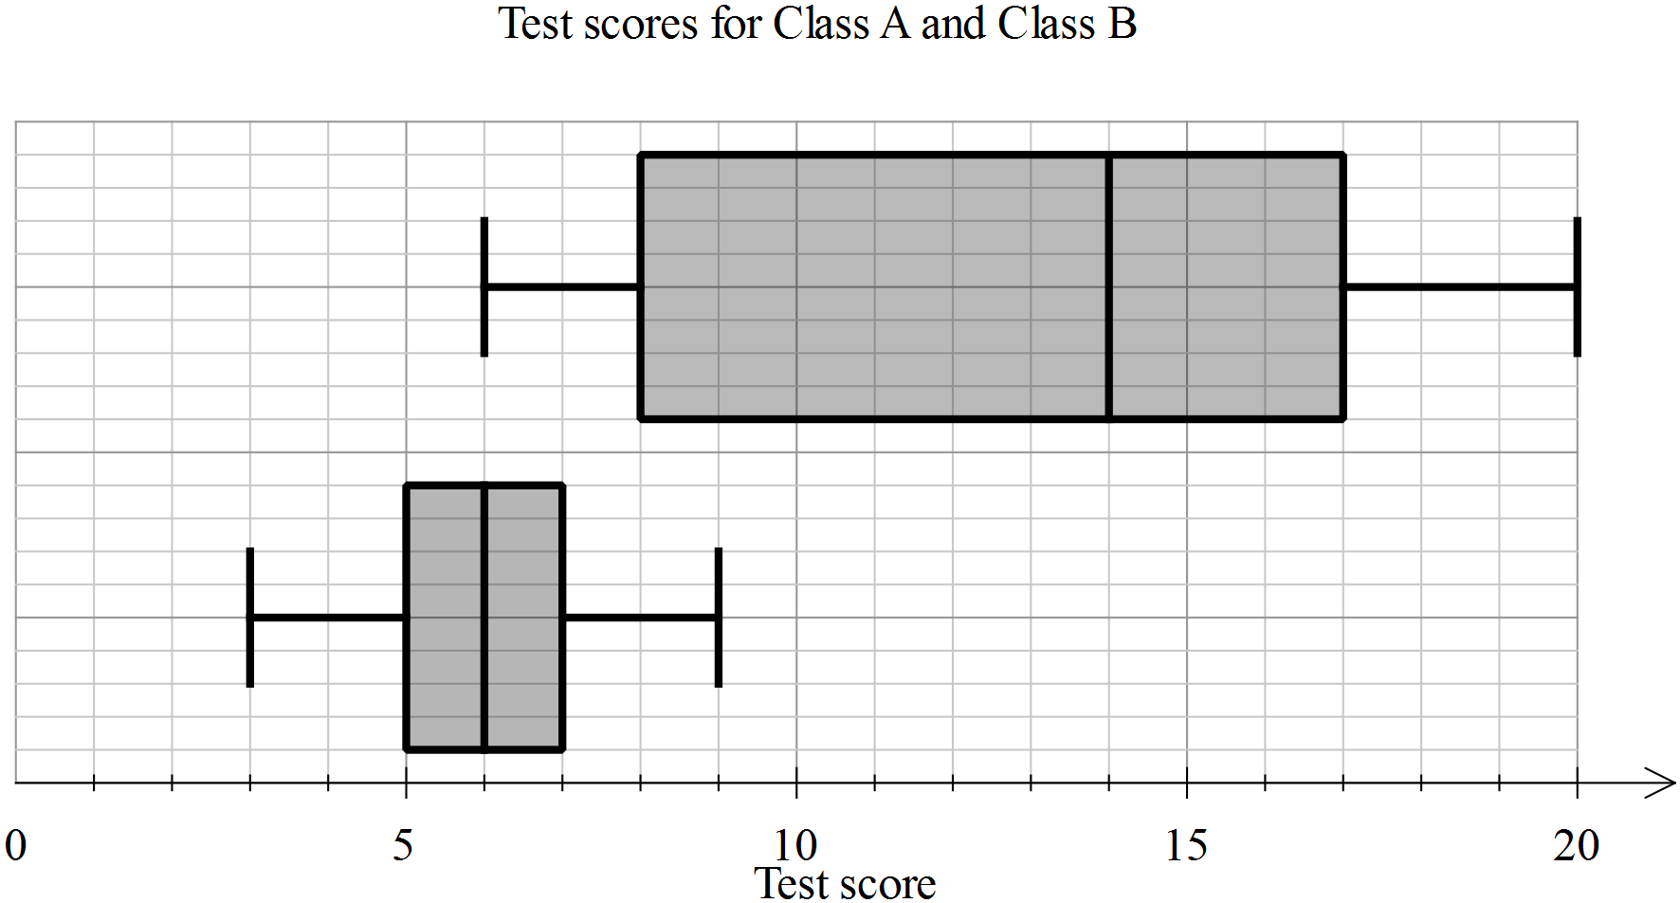

1. Eric is in Class A, he scored 5 on the test. Label the two box plots with their class names.
2. Use the table below to enter the appropriate values for each of the plots.

|  |  |  |
| --- | --- | --- |
| Statistic | Class A | Class B |
| Minimum |  |  |
| First quartile |  |  |
| Median |  |  |
| Third quartile |  |  |
| Maximum |  |  |

Calculate the range and interquartile range for each class, showing the working, in the table below.

|  |  |  |
| --- | --- | --- |
| Statistic | Class A | Class B |
| Range |  |  |
| Interquartile range |  |  |

1. In each of the statements below, write A and B as appropriate to make the statement true.

* Class ___ has a much greater range than Class ___
* The minimum for Class ___ is the same as the median for Class ___
* For Class ___, the second and third quartiles are the same width, whereas for Class ___, the second quartile is much greater than the third quartile.

END OF TEST